**Test Plan**

Project Name: Fraction Runner

Team Name: Team DBA

Team Members: (we are all involved with the testing process)

* Gregory Shelton gpsc7c@umsl.edu
* Maija Garson mmgzzn@umsl.edu
* Kayla Thurman kethurman@mail.umsl.edu
* Sedaf Shakeel ssmkh@missouri.edu
* James Platt jbpkcd@mail.umsl.edu

Revision History:

04/18/2023 – 1st Draft

04/20/2023 – Revision after group discussion

**Section 1: Introduction**

In this game, the object is to see how long you can stay alive.

Upon start, the player is asked to write a number.

The game uses the player’s number to create a repeating decimal that is the ground for the character to run on.

As the character runs, there will be various obstacles the character must avoid or attack.

The character runs on top of the numbers using Jump, Duck, or Attack to stay alive.

When the character collides with an obstacle, the game is over.

The player that stays alive the longest time is the winner.

To encourage replay, players can choose between 3 different characters.

Different number entries will create a different environment for characters to run on.

Players can play against themselves and also others to get the high score on the scoreboard.

The educational purpose of the game is to introduce a mathematical process. The players will learn how it works and functions.

**Section 2: Items to be tested (Database)**

2.1 Connect to Database (DB) – connect with no errors

Date clear box tested: Result: Tester:

2.2 Ensure lack of access to DB is reported – only those with access are allowed in.

Error message is given if user doesn’t have access.

2.3 Ensure user can input digit string and DB can store it in a fraction

2.4 DB keeps track of previous player’s numbers – game will show if the string has

previously been used.

2.5 Correctly insert a new user with blank points and digits into DB – testing sign up functionality

2.6 Report if a user name is already taken – must have an error message

2.7 DB keeps user high scores and number string history

2.8 Delete user – make sure user can’t be deleted without correct password

2.9 Password / user verification – ensure correct password acceptance

2.10 Scoreboard functionality – saving highest 100 ranked users, player history, etc.

2.11 Test log out functionality – ensure session ends after log out

2.12 Ensure session does not break or crash between web pages / long running sessions

2.13 Ensure user can’t access log in page while already logged in

2.14 Check HTML and CSS on site displays correct data and visuals while moving between pages.

**Items to be tested (Gameplay)**

2.15 Verify when player chooses a character, the character image is correct

2.16 Restrict player input for digit string to a 1-9 digit sequence

2.17 Start game when player presses start button

2.18 Display the number string that player entered correctly

2.19 Verify that character performs correct action on pressing the associated button (i.e. character jumps when jump button is pressed, ducks when duck button is pressed, Etc.)

2.20 Character sprite animates appropriately as it moves

2.21 Background and number string scroll correctly throughout gameplay

2.22 Objects spawn and move across the screen from the right and despawn as they leave the screen on the left

2.23 When player collides with an object, triggers lose state

2.24 When player collides with a destructible object while character is in the attacking state, object is destroyed

2.25 Score increases as expected while game is playing and stops when player dies

2.26 At Game Over, display screen has option to restart game and option to go to scoreboard or return to homepage

2.27 Each button on the Game Over screen takes player to correct webpage

**Section 3: Test team – Signatures** (Sign off using tester’s initials)

* Gregory Shelton - GS
* Maija Garson - MG
* Kayla Thurman - KT
* Sadaf Shakeel - SS
* James Platt - JP

Appendix: User Manual

**User Manual**

Welcome to Fraction Runner, an educational running game!

In this game, the object is to see how long you can stay alive.

Upon start, the player is asked to write a number.

The game puts player’s number in a fraction as the numerator over the same number of 9s in denominator.

(Example: 443 becomes 443/999)

The division produces a string of repeating decimals which will be displayed as the ground.

(From our earlier example: 443/999 becomes 0.443443443...)

The player runs on top of the numbers using Jump, Duck, or Attack to stay alive.

The player that stays alive the longest time is the winner.

When running, check out the repeating decimals.

On the Home Screen you will see three choices:

Fraction Runner – select when you are ready to begin the game

Introduction Page – click to learn more about the game and its developers

Top 100 Scoreboard – pick this to see who has the high score

Player will log in on the Log in Page:



Controls:

Each character can perform three different actions:

*Jump – spacebar or click jump

*Attack – enter or click attack

*Duck – down or click duck

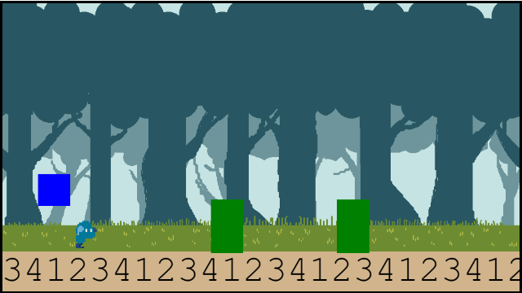

(Screenshot of character ducking)

Gameplay:

At the start, the player is asked to select a character.

There is no skill difference between the characters.

When starting the game, the player must pick a number up to 999,999,999.

After entering the number, the running game begins.

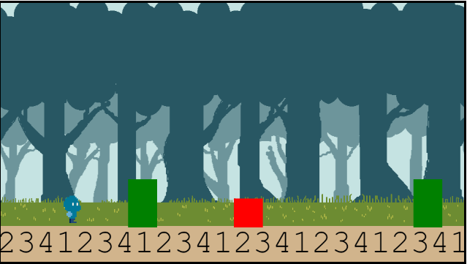

The object of the game is to see how long the player can stay alive.

The timer starts at the beginning of the game.

Once the player has been hit by an object, the game is over.

The time is calculated and added to the Scoreboard.

Fraction Runner Scoreboard

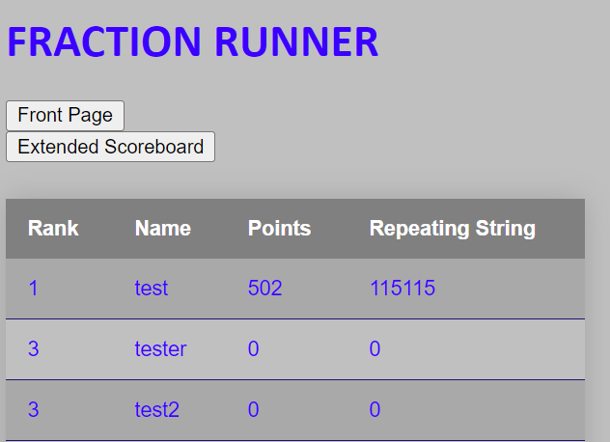

Tips and Tricks:

*There are three different obstacles. Each one can only be defeated by the correct action.

*Use Jump when a hole appears

*Use Duck when a bat is flying

*Use Attack to break a wall

*The runner will speed up as time continues. Stay alert!

We Thank you for playing Fraction Runner.